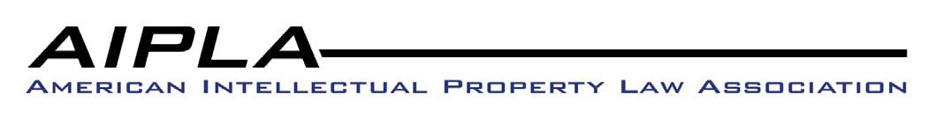
September 22, 2011

The Honorable Deborah Cohn
Commissioner for Trademarks
United States Patent and Trademark Office
P. O. Box 1451
Alexandria, VA 22313-1451

Re: “Changes in Requirements for Specimens and for Affidavits or
Declarations of Continued Use or Excusable Nonuse in Trademark Cases”
76 Federal Register 40839 (July 12, 2011)

Dear Commissioner Cohn:

The American Intellectual Property Law Association (“AIPLA”) appreciates the opportunity to offer comments regarding the United States Patent and Trademark Office’s (“USPTO”) June 12,
2011 Federal Register notice entitled, “Changes in Requirements for Specimens and for

Affidavits or Declarations of Continued Use or Excusable Non-Use in Trademark Cases.”

AIPLA is a national bar association with approximately 16,000 members who are primarily lawyers in private and corporate practice, in government services, and in the academic community. AIPLA represents a wide and diverse spectrum of individuals, companies, and institutions involved directly or indirectly in the practice of patent, trademark, copyright, and unfair competition law, as well as other fields of law affecting intellectual property. Our members represent both owners and users of intellectual property.

AIPLA supports the USPTO’s efforts regarding the proposed changes to its rules and practice in an effort to address the inaccuracies in trademark registrations that may exist due to trademark owners claiming that their marks are in use in commerce on all goods and/or services claimed, when in fact, this is not the case. AIPLA agrees that having the USPTO play a role reviewing additional evidence of use of a mark may be a potentially effective way to address the issue concerning trademark owners “over-claiming” the actual use of their marks in commerce.

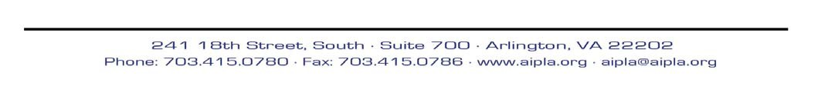

The summary of the proposed rules states that a purpose of the rulemaking is to “determine whether and to what extent a general problem may exist, and consider measures to address it, if necessary.” 76 Fed. Reg. 40839. Those rules would enable Examining Attorneys and Post Registration Examiners to request additional evidence of use in all cases, but they mention no criteria for choosing the cases which require additional evidence of use. Therefore, the request appears left to the discretion of the USPTO. Without guidelines, the burden of providing additional evidence of use would likely fall on applicants and registrants with long identifications or multi-class applications or registrations.

AIPLA supports the USPTO’s authority to collect information in order to determine the extent to which over-claiming may exist. However, the proposed rules would provide such broad authority that, without further guidelines, the rules could be implemented to create an unfair burden on certain trademark owners.

We acknowledge that the Supplementary Information in the notice states that the USPTO “currently has no plans to implement such requirements in all cases, and instead is likely to apply the rules in a ‘small subset of cases.’” 76 Fed. Reg. 40840. However, without further guidelines, the following are some current concerns of AIPLA.

• In the context of pre-registration, the existing rules currently provide Examining

Attorney’s the authority to request additional specimens. TMEP 904.01(a) More Than One Item Specified in a Class
If more than one item of goods or more than one service is specified in one class in an application, it is usually not necessary to have a specimen for each product or service. However, if the range of items is wide or contains unrelated articles, the Examining Attorney may request additional specimen(s) under 37 C.F.R. § 2.61(b). See TMEP
1402.03 regarding broad identifications, TMEP 1402.03(b) regarding house marks, and

TMEP 1402.03(c) regarding marks for a full line of a genre of products.

• The proposed rules amend Rule 2.61(b) to read “the Office may require the applicant to furnish information and exhibits and affidavits or declarations as may be reasonably necessary to the proper examination of the application, or for the Office to assess the accuracy and integrity of the Register.”

It is unclear why this additional requirement is necessary, taking into account that Examining Attorneys already have the authority to request additional specimens under current Rule 2.61(b). We are also concerned that, while the goal may be to determine the extent to which over-claiming exists in the context of pre-registration, the exercise may impact domestic applicants more than the Section 44 and Section 66 applicants who are not required to submit any evidence of use, even though the identification of goods or services in Section 44 and Section 66 applications are often quite lengthy.

To the extent that the authority currently exists for Examining Attorneys to request additional specimens, it does not seem necessary to amend the rules for pre-examination since such authority exists under the current rules.

• However, given the burden that the request for additional specimens can impose on an applicant, AIPLA suggests that specific guidelines should be enacted to guide the exercise of discretion in requesting additional specimens. For example, AIPLA proposes that a request for additional specimens must be based on something more than the number of goods or services included in an application. Specifically, an examiner should be required to identify some other fact-based reason that justifies a request for additional specimens. An example might be a case where an applicant’s website identifies a use of the mark on or in connection with certain goods or services but does not show use of the mark on or in connection with other goods and services. The TMEP should be revised to include specific guidelines for the circumstances under which an examiner can request additional specimens so that the request is governed by standards and is not left solely to an individual examiner’s discretion, which can vary from examiner to examiner.

• In the current rules, in the context of Post Registration, there is not currently a counterpart to Rule 2.61(b) that would enable Post Registration examiners to request additional specimens. Therefore, AIPLA would be in favor of implementing proposed Rule 2.61(h) to the extent it conforms to existing Rule 2.61(b).

• Post Registration examination of claims of use in commerce in maintenance filings is the first time owners of registrations under Section 44 and Section 66 are required to submit a claim of use of a mark and a specimen for each class. These claims should be examined under the same criteria applied to owners of use-based applications.

• During the pre-registration stage, an applicant who is unable to provide an acceptable specimen has the option of converting certain goods/services to a Section 1(b) application. In Post Registration examination, the alternative for the registrant unable to provide a specimen is to delete those goods/services.

If a registrant cannot provide an additional specimen requested by Post Registration, the USPTO should allow registrants to voluntarily request deletion of goods/services as an alternative to providing the requested additional specimen without incurring any vulnerability as to the remaining goods/services in the registration. In other words, this should be permitted without being viewed as an admission that the goods/services were improperly over-claimed in the initial filing.

AIPLA appreciates the opportunity to provide these comments.

Sincerely,

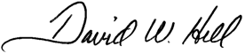

David W. Hill
AIPLA President

