Public Roundtable-Registration Amendments to Identifications of Goods & Services
Friday April 11, 2014
Event Time: 2:00 p.m. EST
Event number: 998491327
Password: 1111
Instructions for On-campus, Teleworkers & Public
(Those on-campus are asked to attend the live event in the Madison South Auditorium, if possible)

Click link below to sign-in to the webcast session:

https://uspto-events.webex.com/uspto-events/onstage/g.php?d=998491327&t=a

- Note: the event status, date and time are on the left hand side. You will not be able to join the event until 15 minutes before start time. Please note you will not be able to log into the event prior to the 15 minute window (The boxes under Join Event Now will be greyed out and you will not be allowed to enter your information into the boxes.)
- Once the event has been opened, you may join the event by filling in the blanks under the "Join Event Now".
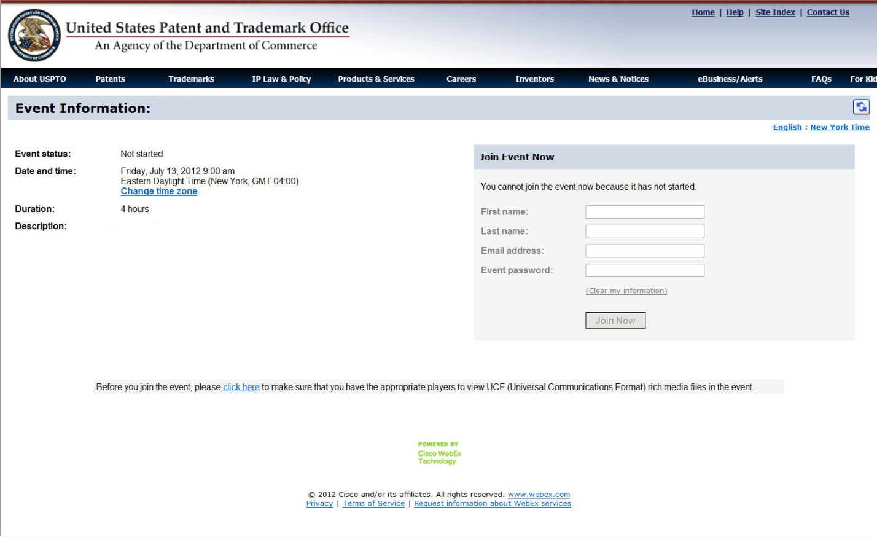
2. Sign-in using your first name, last name and email address.
3. Make sure to enter the event password: 1111
4. Click on the “Join Now” button.
5. You may be asked to run a file:

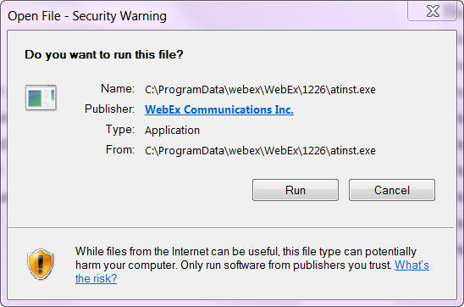

If so, please click the RUN button in order for the event to run properly on your machine.

6. A new browser window may pop up – Please do not click on modify your computer during this time. Your computer is working and will open the page momentarily.

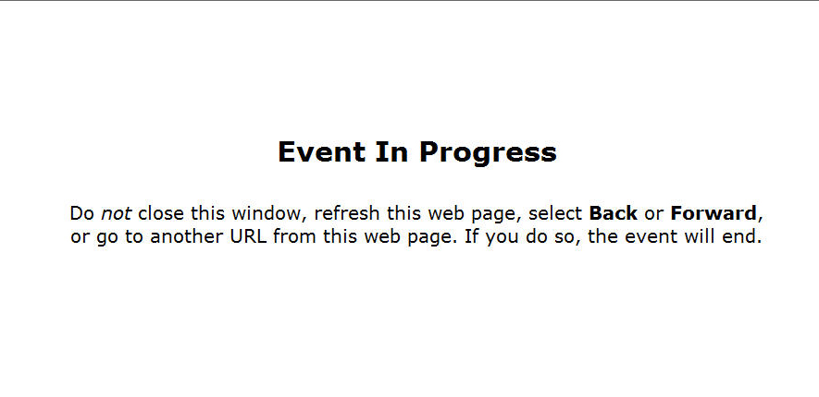

7. The event will open with shared desktop or PowerPoint materials on the left of the browser window and the video, chat and Q&A sections on the right. The video will have captioning in it.

7.5. If you get a pop up screen for a teleconference:

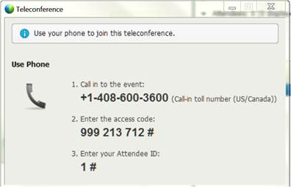

Please close the box and move to the next step.

8. At this time, another pop-up window will ask you to participate in the integrated voice conference. Click the YES button. You will need to use your computer speakers or your headset to listen to the audio portion of the webcast.
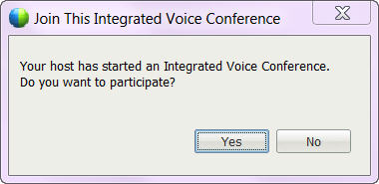

9. Another box will open up. Please look for the box which has the audio and microphone box.
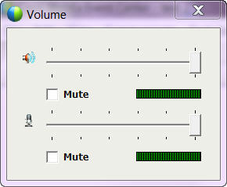

10. In the volume box, the speaker is the top option and the slider will increase or decrease the volume for your computer speakers. Make sure the mute box directly underneath is NOT checked.

However, the microphone option underneath should be CHECKED so that your microphone does not pick up any personal conversations or other sounds during the conference (making it more difficult for others to listen to the speaker).
Assistance
The playback of UCF (Universal Communications Format) rich media files requires appropriate players. To view this type of rich media files in the meeting, please check whether you have the players installed on your computer by going to https://uspto-events.webex.com/uspto-events/onstage/systemdiagnosis.php

If you need assistance with login or if there is a problem with the webcast, please contact the OCIO Service Desk at 571-272-9000

